# Truncation

* Start from the end, propagate backwards

# Type Propagation Phase

* Can see the output (is this inferred or actual)

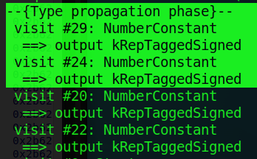

SetOutput

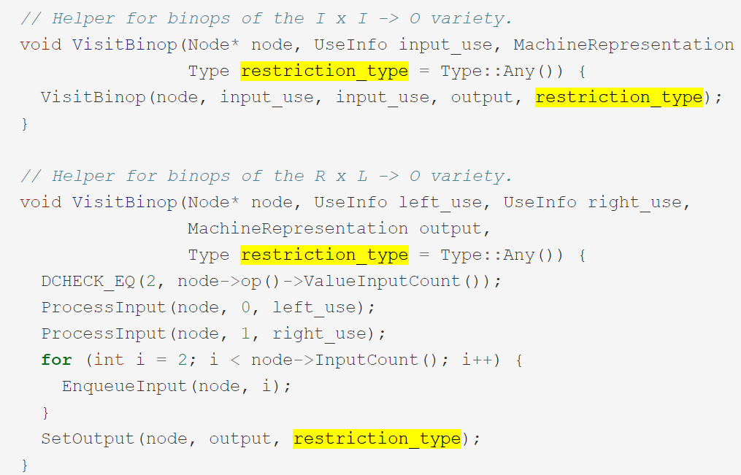

Syntax for SetOutput:

1. Node = current node
2. Restriction_type = output representation

# Enqueue

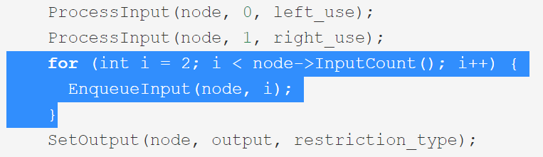

Queueing input to the truncation queue

# ProcessInput

Example:

ProcessInput(node, 1, right_use);

Used to pass truncation to the next node

# Question:

* What actually is truncation and what is it used for?